**TIME   
(WHEN-HOW LONG-HOW OFTEN)**

1. How often are the offices cleaned?  
(A) Two times a week.  
(B) Three times a week.  
(C) Once a day.  
(D) Twice a day.

2. How long did it take to fix the coffee machine?  
(A) All day.  
(B) Two hours.  
(C) All morning.  
(D) Four hours.

3. How long does it take to make eight copies?  
(A) One minute.  
(B) Five minutes.  
(C) Eight minutes.  
(D) One hour.

4. How often has the man tried to call?  
(A) Once.  
(B) One more time.  
(C) Every five minutes.  
(D) Every hour.

5. When does the mail come?  
(A) In the morning.  
(B) At noon.  
(C) In the afternoon.  
(D) In the evening.

6. When was the check sent?  
(A) Today.  
(B) On Friday.  
(C) Last week.  
(D) Yesterday.

7. When did Ms. Wallace join the company?  
(A) The same year as Mr. Chu.  
(B) A month before Mr. Chu.  
(C) A year after Mr. Chu.  
(D) A month after Mr. Chu.

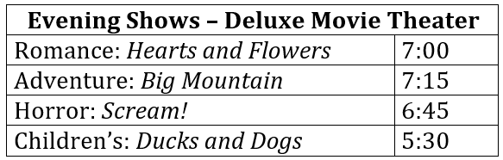8. Look at the graphic. When will the speakers see a movie?  
(A) 5:30.  
(B) 6:45.  
(C) 7:00.  
(D) 7:15.

9. When did the woman visit her aunt?  
(A) A long time ago.  
(B) Last week.  
(C) Yesterday.  
(D) This morning.

10. How long will Ms. Ono be away?  
(A) One week.   
(B) Two weeks.  
(C) Three weeks.